**Department of Computer Science**

**LAB TASK #5**

* **Question 1/Task 1:** Student perspective consisting of at least **8 to 10** properties(process/functions) on the business layer ONLY.

**Answer:**

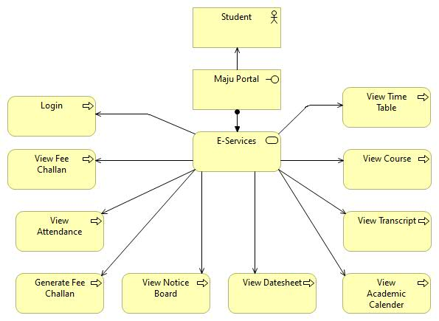

* **Question 2/Task 2:** Admin perspective over business layer

**Answer:**

